|  |  |
| --- | --- |
| **Project Title** | Plan, Schedule, Implement and Test Help desk system |
| **Qualification Name** | Bachelor of Technology in Software Engineering/  Higher Diploma in Software Engineering |
| **Product Name** | BDSE/HDSE - Capstone Project Web Development |
| **Module Name** | Capstone Project Web Development |

|  |  |  |  |
| --- | --- | --- | --- |
| **Student name** | | **Assessor name** | |
| Nithika Minlaka Jayarathne | | Ms.Ei Thandar Khaing | |
| **Date issued** | **Completion date** | | **Submitted on** |
| 21/11/2023 | 30/01/2024 | | 02/02/2024 |
|  | | | |
| **Project title** | **Plan, Schedule, Implement and Test Help desk system** | | |

|  |
| --- |
| **Learner declaration** |
| I certify that the work submitted for this assignment is my own and research sources are fully acknowledged.  Student signature: Date:02/02/2024 |

**PROJECT SCENARIO**

* Manzaneque Limited is a real estate company that specializes in sustainable and eco-friendly properties. The company has been growing rapidly and is now expanding into new markets across the globe. As a result, the IT department is overwhelmed with requests from employees for IT support, and there is no formal system in place to handle these requests.
* To address this issue, the company is planning to implement a new IT Helpdesk system that will streamline the process of logging and tracking helpdesk queries. The new system will enable employees to submit requests online, which will be automatically assigned to helpdesk specialists based on their areas of expertise. The system will also provide real-time updates to employees on the status of their requests.

## **SYSTEM REQUIRED**

* When someone in the company has a problem, they can contact the helpdesk. One of the helpdesk operators will attempt to deal with the enquiry, but if an immediate answer cannot be given the problem is passed to one of several specialists. An Information System is needed to log and track the helpdesk queries. This will enable analysts to see how the equipment is performing overall, whether the helpdesk specialists are sufficiently resourced to solve problems in an acceptable time and whether there are subject areas where employee training is needed.

## 

## **PROPOSED SYSTEM OPERATION**

* When a new call comes into the helpdesk, the names of the caller and helpdesk operator are logged, along with the time of the call, the serial number of the computer and, if relevant, the operating system and software being used
* The caller’s name will be checked against a register of all personnel to retrieve the caller’s ID number, job title and department.
* Their equipment will also be checked against a register of equipment to find the equipment type and make. Their software will be checked to see if it is under a valid license.
* Every call is logged and each problem is given a problem number, which is supplied to the caller so it can be quoted on any subsequent calls about the same problem
* The helpdesk operator will also record notes and descriptions of the problem. A reason for each call is always recorded even if it is just a note to say how desperate the caller is getting (e.g., in the case of a follow-up call)
* When a problem is first reported, the helpdesk operator will also allocate a problem type, selecting it from a list of problem types. It is the skill of the operator to know what problem type is most relevant and how specific the problem is.
* Some problem types are refinements of more general problem types and so it is possible that the problem type allocation may be altered later if more information becomes available.
* When the problem area is identified the helpdesk operator can look up previous problems of the same type to see if the problem has occurred before and, if so, how it was resolved.
* It is also possible to look up previous problems with the same equipment or from the same caller to see if there were other related problems.
* If the problem can’t be solved immediately, the helpdesk operator will use the system to look up which specialist to refer the problem to.
* Each specialist will be an expert in one or more problem types.
* If there is no specialist listed for a more specific problem type, then a specialist from the more general problem type will be used.
* The system will also list how many problems the specialist is currently working on so that if there is more than one specialist for a problem type, the specialist who is currently the least loaded can be allocated.
* When a problem is eventually resolved, the helpdesk operator or the specialist will log the date and time it is resolved and record some indication of how the problem was resolved and the time taken to resolve the problem.

**PROJECT OBJECTIVES**

1. Efficient Problem Resolution:

* Enable the helpdesk operators to efficiently resolve hardware and software problems for the company's IT systems.
* Provide a systematic process for logging and tracking helpdesk queries.

1. Documentation and Analysis:

* Log essential information for each call, including caller's name, helpdesk operator, time of the call, computer serial number, and relevant software details.
* Retrieve additional information about the caller, such as ID number, job title, and department.
* Check equipment and software against registers to ensure validity and proper licensing.

1. Problem Categorization:

* Allow helpdesk operators to allocate a problem type to each reported issue, selecting from a predefined list.
* Enable refinement of problem types based on additional information, if available.

1. Knowledge Base and Historical Data:

* Maintain a knowledge base that allows operators to look up previous problems of the same type to facilitate quicker resolutions.
* Provide the ability to check historical problems related to the same equipment or from the same caller.

1. Specialist Allocation:

* Identify and assign specialists based on the type of problem reported.
* Consider specialists' workload to ensure optimal allocation and prevent overloading.

1. Resolution Tracking:

* Record the date and time when a problem is resolved.
* Document the resolution details and the time taken to resolve the problem.

1. User-Friendly Interface:

* Design an intuitive and user-friendly interface for helpdesk operators and specialists.

1. System Performance Optimization:

* Optimize the web application system for performance efficiency.

1. Training and Resource Planning:

* Provide insights into overall equipment performance and the sufficiency of resources for problem resolution.
* Identify areas where employee training is needed based on recurring problems.

1. Comprehensive Testing:

* Develop and implement a comprehensive testing plan to ensure the functionality, performance, and reliability of the Help Desk System.

1. Documentation and Reporting:

* Generate reports that offer insights into the overall performance of the helpdesk, specialists' workload, and problem resolution trends.

1. Scalability and Flexibility:

* Design the system to accommodate future expansion and changes in the company's IT infrastructure.

**PROJECT SCOPE**

The scope of the project involves the development of a comprehensive Help Desk System for Manzaneque Limited, focusing on the following key aspects:

1. **Help Desk Functionality:**

* Implement a system to log, track, and manage helpdesk queries related to hardware and software issues.

1. **User Authentication and Access Control:**

* Include secure user authentication mechanisms to ensure that only authorized personnel can access and manipulate data within the system.

1. **Data Logging and Retrieval:**

* Capture and store essential information for each helpdesk call, including caller details, operator information, time of the call, computer details, and relevant software information.

1. **Problem Categorization:**

* Develop a system for helpdesk operators to categorize and allocate problem types, with the ability to refine categories based on additional information.

1. **Knowledge Base and Historical Data:**

* Create a knowledge base that allows operators to look up previous problems of the same type and retrieve historical data related to equipment or specific callers.

1. **Specialist Allocation:**

* Design a mechanism for identifying and assigning specialists based on the type of problem reported, considering specialists' workload to ensure optimal allocation.

1. **Resolution Tracking:**

* Implement functionality to record the date and time of problem resolution, along with detailed information on how the problem was resolved and the time taken.

1. **User Interface:**

* Develop an intuitive and user-friendly interface for both helpdesk operators and specialists.

1. **Performance Optimization:**

* Optimize the web application system for efficient performance, considering the potential volume of helpdesk queries.

1. **Reporting and Insights:**

* Generate reports providing insights into the overall performance of the helpdesk, workload distribution among specialists, and trends in problem resolution.

**11. Training Recommendations:**

* Include features that can suggest areas where employee training is needed based on recurring problems.

**12. Testing:**

* Develop and execute a comprehensive testing plan to ensure the reliability, functionality, and security of the Help Desk System.

1. **Project Constraints:**
2. **Budgetary Constraints:**

* Develop the system within the allocated budget for IT projects.

1. **Time Constraints:**

* Adhere to the project timeline to ensure timely delivery of the Help Desk System.

1. **Resource Limitations:**

* Work within the existing IT infrastructure and resources available to Manzaneque Limited.

1. **Security and Compliance:**

* Ensure that the system complies with relevant security standards and data protection regulations.

1. **Scalability Challenges:**

* Address potential scalability challenges to accommodate future expansion and changes in the company's IT requirements.

1. **Integration with Existing Systems:**

* Integrate the Help Desk System with existing IT systems and databases to ensure seamless operations.

1. **User Training and Adoption:**

* Consider the need for user training and provide sufficient documentation for system adoption by helpdesk operators and specialists.

1. **Technical Constraints:**

* Work within the technical capabilities and limitations of the chosen development environment and technology stack.

1. **Feedback Mechanism:**

* Establish a feedback mechanism for continuous improvement based on user experiences and system performance.

1. **Legal and Ethical Considerations:**

* Adhere to legal and ethical considerations related to data privacy, confidentiality, and workplace regulations.

**RISK ANALYSIS AND EVALUATION**

| **Risk** | **Description** | **Impact** | **Mitigation** |
| --- | --- | --- | --- |
| **User Adoption** | Users may resist or struggle to adopt the new system, leading to inefficiencies. | Operational disruptions, reduced productivity. | - Conduct user training sessions. - Provide clear documentation. - Involve users in the design process. |
| **Data Security** | Unauthorized access to sensitive information in the helpdesk system. | Data breaches, loss of trust. | - Implement robust authentication and access controls. - Use encryption for sensitive data. - Regularly audit and monitor system access. |
| **Incomplete Requirements** | Users may not provide all necessary requirements initially, leading to feature gaps. | Project delays, rework. | - Engage in continuous communication with users. - Conduct thorough requirement gathering sessions. - Be prepared for iterative updates. |
| **Technological Changes** | Rapid changes in technology may affect the compatibility and longevity of chosen tools. | System obsolescence, increased development time. | - Regularly assess and update technology choices. - Build flexibility into the system architecture to accommodate future changes. |
| **Scope Creep** | Continuous changes to project scope beyond initial requirements. | Project delays, increased development costs. | - Clearly define and document the project scope. - Implement a change management process to evaluate and approve scope changes. |
| **Resource Constraints** | Insufficient resources (human, financial, technological) allocated for the project. | Delays, incomplete features. | - Conduct a thorough resource assessment before the project starts. - Continuously monitor and adjust resource allocation as needed. |
| **Integration Challenges** | Difficulties integrating the Help Desk System with existing systems or databases. | Data inconsistencies, operational disruptions. | - Conduct a comprehensive analysis of existing systems and databases. - Plan and test integration thoroughly before deployment. |
| **Dependency on Key Personnel** | Dependence on specific individuals for critical tasks. | Bottlenecks, project delays. | - Cross-train team members to handle critical tasks. - Document critical processes and procedures to reduce dependency on specific individuals. |
| **Quality Assurance Issues** | Insufficient testing leading to undetected bugs or performance issues. | System failures, user dissatisfaction. | - Develop a comprehensive testing plan. - Implement automated testing where applicable. - Conduct thorough testing at each development stage. |
| **Vendor Reliability** | Dependence on third-party vendors for critical components. | Delays, system instability. | - Select reputable vendors with a track record of reliability. - Have contingency plans in place in case of vendor-related issues. |
| **Change Resistance** | Resistance from employees to adapt to new processes and workflows. | Decreased productivity, employee dissatisfaction. | - Implement change management strategies. - Communicate the benefits of the new system to employees. - Provide training and support during the transition. |

**CHOSEN SDLC MODEL FOR THE HELP DESK SYSTEM**

Given the nature of the Help Desk System and the provided project details, the **Incremental Model** or the **Iterative Model** would be suitable.

**Incremental Model:**

**Reasons:**

* **Phased Implementation:** Since the project involves developing a Help Desk System with various components, an incremental approach allows for phased implementation. This means each phase (or increment) could represent a set of functionalities, making it easier to manage and test.
* **Early Deliverables:** The incremental model provides the advantage of delivering functional pieces of the system early in the development process. This can be beneficial for immediate testing and feedback.
* **Flexibility for Changes:** As the system evolves through increments, there is flexibility to accommodate changes or enhancements in later stages based on user feedback or changing requirements.
* **Risk Management:** Risks can be better managed as each increment is a mini-project with its own planning, design, implementation, and testing phases. This allows for early identification and mitigation of risks.
* **Continuous User Involvement:** Incremental development encourages continuous user involvement and feedback, aligning well with the iterative nature of help desk systems that often require user input for refinement.

**Iterative Model:**

**Reasons:**

* **Progressive Refinement:** The iterative model is well-suited for projects where requirements are expected to evolve. It allows for progressive refinement of the system through multiple iterations.
* **Feedback Loop:** It provides a continuous feedback loop, enabling adjustments to be made at each iteration based on the feedback received from users and stakeholders.
* **Risk Management:** Similar to the incremental model, the iterative model supports effective risk management by identifying and addressing issues early in the development process.
* **Adaptability:** Help desk systems may have evolving requirements or changing user needs. The iterative model's adaptability to changes makes it suitable for such scenarios.
* **Prototyping:** The iterative model often involves the creation of prototypes, which can be beneficial for refining user interfaces and ensuring that the system aligns closely with user expectations.

**USER & SYSTEM REQUIRMENTS**

User Requirements:

* The helpdesk system should be user-friendly, allowing users to easily submit and track their queries.
* Users should be able to submit queries through multiple channels, such as phone, email, and an online portal.
* The system should provide users with real-time updates on the status of their queries, including estimated resolution times.
* Users should be able to view a history of their past queries and their resolutions.
* The system should allow users to rate the quality of the support provided by the helpdesk specialists.
* The system must allow users to create and submit helpdesk tickets online.
* Users should be able to track the status of their helpdesk tickets and receive updates on progress.
* The system must provide an intuitive interface for users to describe their problems and request assistance.
* Users must be able to access the system from any device with an internet connection.
* The system should allow users to search for self-help resources to solve common issues.
* Users should have the option to escalate their tickets to higher levels of support if their problems are not resolved in a timely manner.
* The system must provide a secure and confidential way for users to submit sensitive information related to their issues.
* The system should allow users to rate their experience with the helpdesk support team and provide feedback.
* Users must be able to easily access information about their equipment, such as its warranty status and service history.
* The system should provide users with regular updates on system maintenance and downtime.

System Requirements:

* The system should be designed to handle a high volume of queries and be scalable to accommodate future growth.
* The system should have robust query management functionality, including the ability to assign, prioritize, and track queries.
* The system should be integrated with a knowledge base that allows helpdesk specialists to easily access information and resources to help them resolve queries efficiently.
* The system should provide detailed reporting and analytics on query resolution times, user satisfaction, and specialist performance.
* The system should have robust security measures in place to protect user data and prevent unauthorized access.
* The system should be able to handle a large volume of helpdesk queries efficiently and effectively.
* The system should be scalable to accommodate future growth and expansion of the company.
* The system should have a user-friendly interface that is easy to navigate and understand.
* The system should be accessible via a web-based interface, allowing users to access it from anywhere with an internet connection.
* The system should be able to integrate with other existing systems within the company such as inventory management and CRM systems.
* The system should be able to generate automatic notifications to users regarding the status of their queries and provide updates on progress.
* The system should provide the ability to assign queries to specific technicians or teams for resolution.
* The system should have a search function to allow users to quickly find previously logged queries and their resolution status.
* The system should provide real-time reporting and analytics on the performance of the helpdesk, including query resolution times, user satisfaction, and technician performance.
* The system should have robust backup and disaster recovery capabilities to ensure that data is not lost in the event of system failures or disasters.

Hardware Requirements:

* Servers: The IT Helpdesk system requires a dedicated server for hosting the database and application servers for processing user requests.
* Storage Devices: Adequate storage devices should be provided to store system data, such as databases, log files, and backups.
* Workstations: The IT Helpdesk operators and specialists require workstations equipped with the necessary hardware, such as computers, keyboards, and mice.
* Networking Equipment: The system requires routers, switches, firewalls, and other networking equipment to support communication between system components.
* Printers: The IT Helpdesk system requires printers to produce reports and other documentation.
* Backup Equipment: Backup equipment such as Uninterruptible Power Supply (UPS) should be installed to avoid data loss in case of power outages.
* Security Equipment: The system requires adequate security equipment such as surveillance cameras, biometric scanners, and access control systems to protect sensitive data and hardware.
* Audio/Visual Equipment: The system requires audio/visual equipment such as speakers, projectors, and monitors to support training sessions and presentations.
* Mobile Devices: The IT Helpdesk operators and specialists require mobile devices such as smartphones and tablets for remote access to the system.
* Virtualization Environment: The IT Helpdesk system may require a virtualization environment to support multiple instances of the application servers and databases to enhance scalability and high availability.

**GANETT CHART**

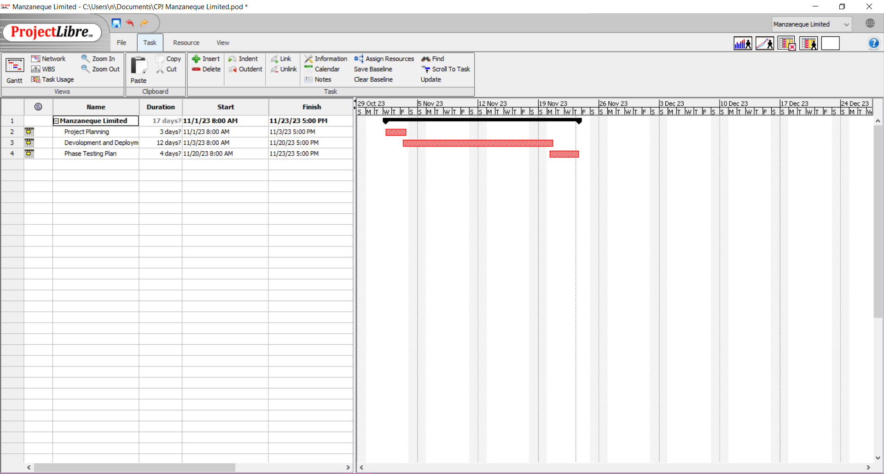

**MILE STONE SCHEDULE**

| **Milestone** | **Duration** | **Tasks** |
| --- | --- | --- |
| **1. Project Kickoff** | **Week 1-2** | - Define project scope, objectives, and stakeholders. |
|  |  | - Establish project team roles and responsibilities. |
|  |  | - Initial project planning. |
| **2. User and System Requirements** | **Week 3-4** | - Gather and finalize detailed user requirements. |
| Specification |  | - Document system requirements. |
|  |  | - Review and get approval from stakeholders. |
| **3. Design Phase** | **Week 5-8** | - Develop UML design representations (Use Case Diagram, Activity Diagram, DFD). |
|  |  | - Create algorithmic design (Flow Chart or Algorithm). |
|  |  | - Develop behavioral design (Use Case Diagram, Activity Diagram, or DFD). |
|  |  | - Create data design (ERD or EERD Diagram, Data Dictionary). |
| **4. Development and Deployment Environment** | **Week 9-10** | - Identify and set up a suitable development environment. |
| Setup |  | - Begin the development of the Help Desk System. |
| **5. Increment 1 Implementation** | **Week 11-14** | - Implement the first increment of the Help Desk System. |
|  |  | - Conduct initial testing and debugging. |
|  |  | - Collect feedback from users and stakeholders. |
|  |  |  |
| ... (Repeat for additional increments) |  |  |
| **Final Testing and Refinement** | **Week 15-16** | - Perform comprehensive testing of the entire system. |
|  |  | - Refine and address any identified issues. |
| **6. Evaluation and Report** | **Week 17-18** | - Review how the application meets the needs of the requirements and problem definition. |
|  |  | - Critical analysis of strengths and weaknesses. Discuss potential improvements and enhancements. |
| **7. Final Deployment** | **Week 19-20** | - Deploy the final version of the Help Desk System. |
|  |  | - Provide necessary training to end-users and support staff. |
| **8. Project Closure** | **Week 21-22** | - Finalize project documentation. |
|  |  | - Conduct a project review and lessons learned session. |
|  |  | - Obtain project sign-off from stakeholders. |

**UML DESIGN**

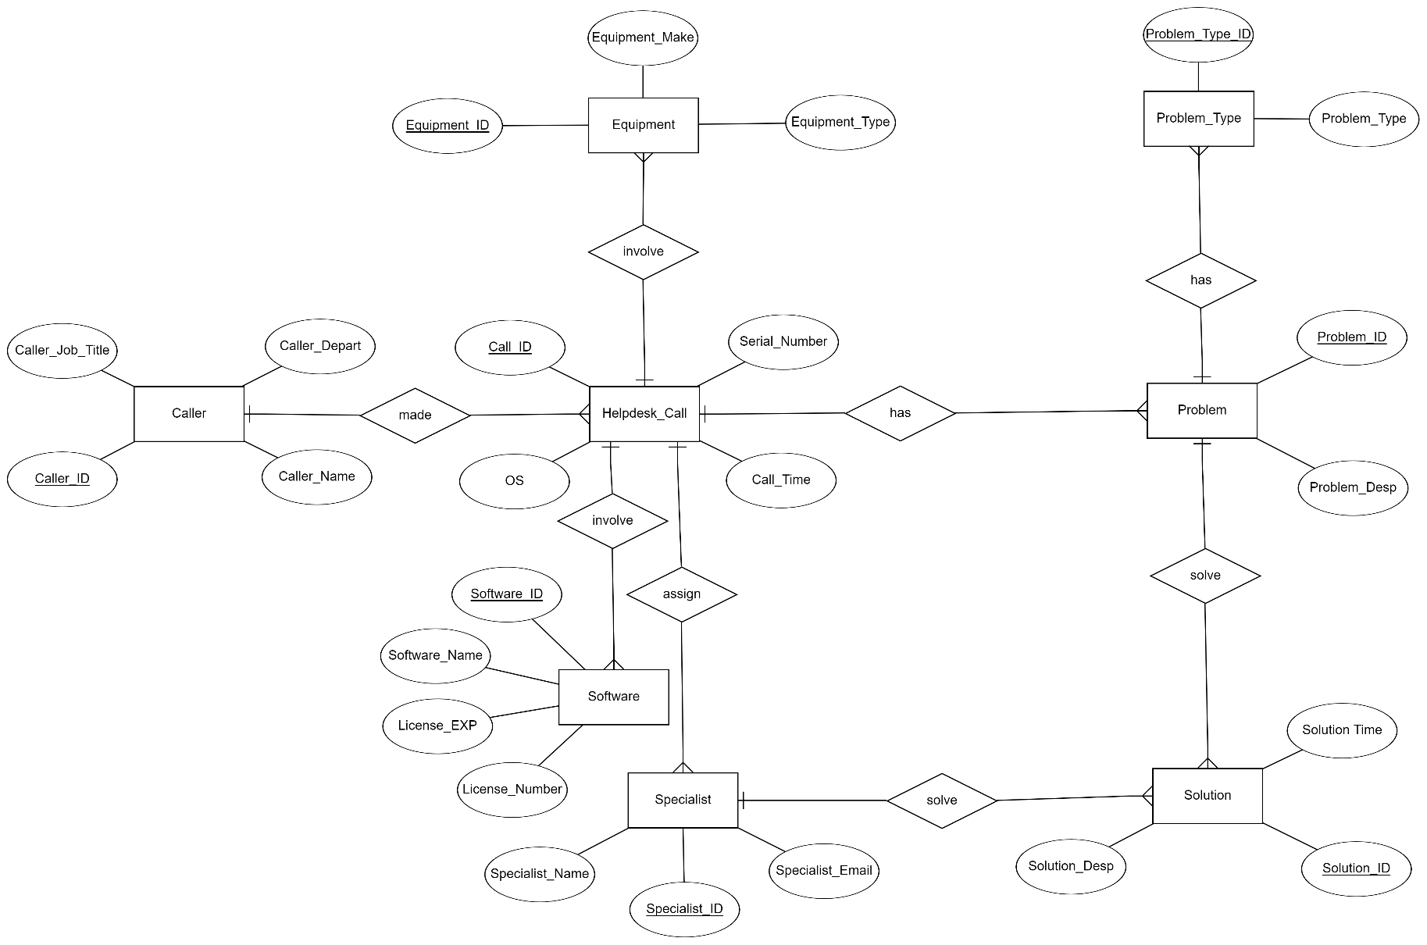

**Logical Design**

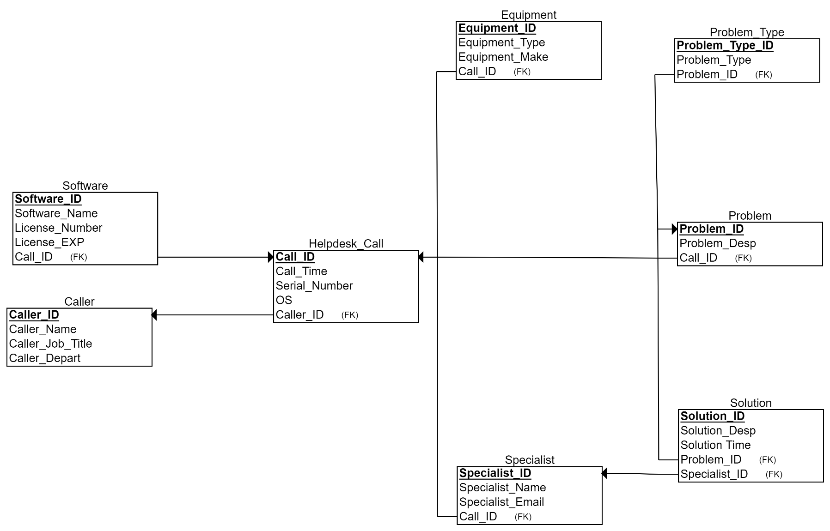

**ER DIAGRAM**

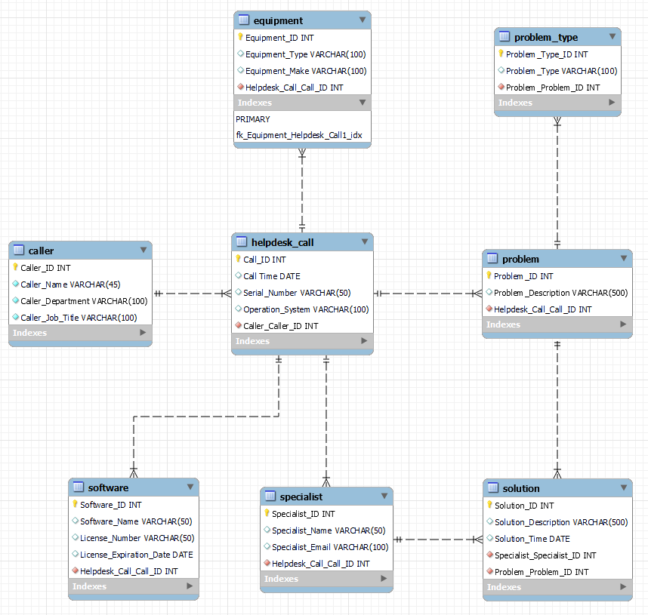

**UML CASE DIAGRAM**

Flow chart 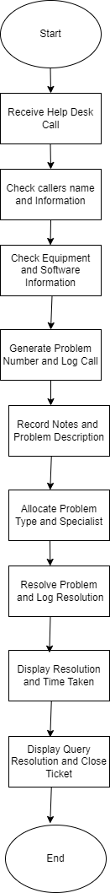

**FLOW CHART**

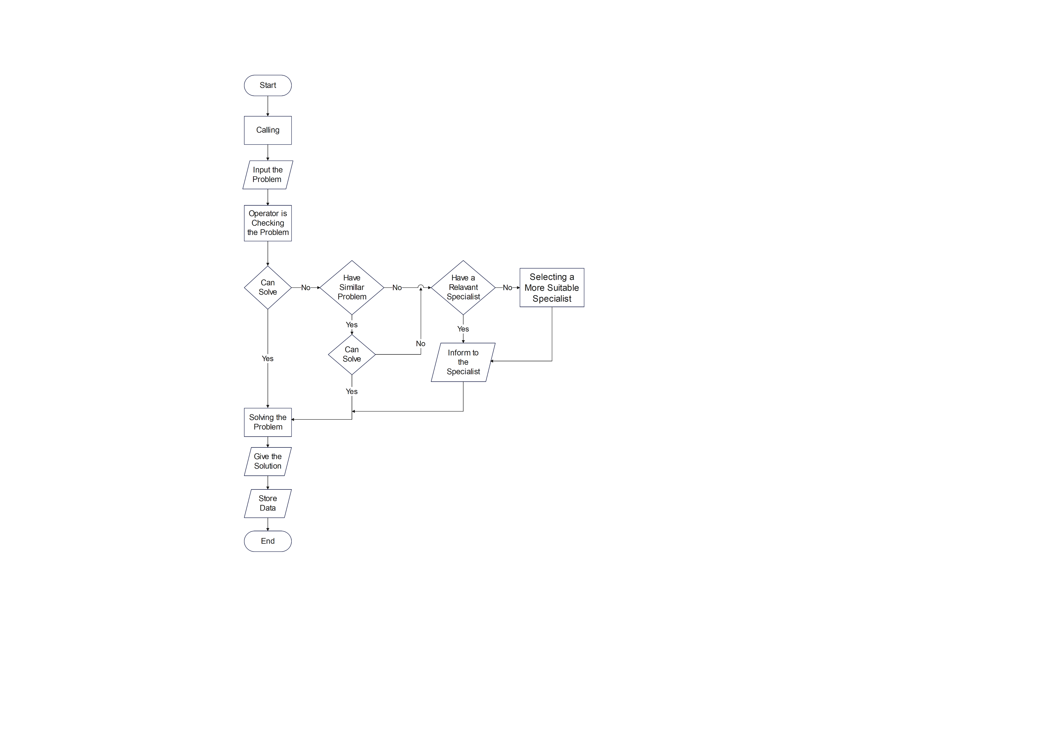

Business System Options (BSO) for Help Desk System:

* **Custom Web Application:**
* Developing a custom web-based application tailored to the specific needs of Manzaneque Limited's IT Helpdesk.

Advantages

* 1. Provides a fully customizable solution
  2. Aligning perfectly with the company's unique requirements.

Disadvantages

1. Longer development time and potentially higher initial costs.

* **Commercial Helpdesk Software:**
* Purchasing and implementing a pre-built helpdesk software solution available in the market.

Advantages:

1. Quicker implementation
2. Potential cost savings
3. May have features already aligned with industry best practices.

Disadvantages

* May require customization to meet all specific needs; ongoing licensing costs.
* **Integrated IT Service Management (ITSM) System:**
* Implementing a comprehensive ITSM system that not only handles helpdesk queries but integrates with other IT functions.

Advantages:

* Streamlines IT processes
* Allows for better tracking of overall IT performance
* Can offer scalability.

Disadvantages

* May involve a more significant change in existing processes
* Training for staff may be required.

**Business System Option 4: Open Source Helpdesk Solution**

* Utilizing an open-source helpdesk solution involves implementing a software system with publicly available source code. This option allows for customization and flexibility without the high costs associated with proprietary solutions.

**Advantages:**

* **Cost-Effective:** No licensing fees; potential cost savings.
* **Community Support:** Benefit from a community of developers and users.
* **Customization:** Can be tailored to specific business needs.
* **Transparency:** Full access to source code for transparency and control.
* **Scalability:** Adaptable to business growth without additional licensing costs.

**Disadvantages:**

* **Limited Vendor Support:** Relies on community support or in-house expertise.
* **Potential Security Concerns:** Security measures may require closer attention.
* **Integration Challenges:** Compatibility issues with other systems.
* **Documentation Variances:** Quality and completeness of documentation can vary.
* **Dependency on Community:** Updates and patches may depend on community contributions.

Business System Option 5: Hybrid Solution

* A hybrid solution combines elements of custom development with pre-built modules. This approach allows for flexibility and customization while leveraging existing solutions for certain functionalities.

**Advantages:**

* **Tailored Functionality:** Customized modules for specific business needs.
* **Quick Implementation:** Faster deployment for pre-built modules.
* **Cost Flexibility:** Control costs by selecting pre-built or custom components.
* **Scalability:** Easily expand and modify with changing business requirements.
* **Vendor Support for Modules:** Benefit from support for pre-built components.

**Disadvantages:**

* **Integration Complexity:** Requires seamless integration between custom and pre-built components.
* **Development Skills Needed:** Proficiency in both custom and pre-built solutions.
* **Dependency on Vendors:** Relies on vendors for support and updates.
* **Maintenance Challenges:** Ongoing maintenance may involve both custom and pre-built aspects.
* **Potential for Over-customization:** Risks of complicating the system with excessive customization.

Technical System Options (BSO) for Help Desk System:

Technical System Option 1: Web Application Framework (e.g., Django, Ruby on Rails)

* Using a web application framework provides a structured and efficient way to develop a custom web-based IT Helpdesk system. Frameworks like Django or Ruby on Rails offer pre-built components, speeding up development and ensuring best practices.

**Advantages:**

* **Rapid Development:** Frameworks offer ready-made components for faster development.
* **Scalability:** Frameworks often support scalability as the application grows.
* **Community Support:** Benefit from a community of developers for problem-solving.
* **Security Features:** Frameworks often come with built-in security features.
* **Code Organization:** Promotes code organization and maintainability.

**Disadvantages:**

* **Learning Curve:** Developers need to learn the specific framework.
* **Limited Flexibility:** Some frameworks may restrict certain design choices.
* **Potential Bloat:** Unused features in the framework may lead to unnecessary complexity.
* **Dependence on Framework:** Updates and changes in the framework may impact the system.
* **Compatibility Challenges:** Integrating with existing systems may require extra effort.

Technical System Option 2: Database Management System (DBMS) - MySQL or PostgreSQL

* Choosing an appropriate Database Management System (DBMS) is crucial for storing and managing data efficiently. MySQL or PostgreSQL, for example, can be employed to ensure data integrity and security.

**Advantages:**

* **Data Integrity:** DBMS ensures consistency and accuracy of data.
* **Scalability:** Capable of handling growing amounts of data.
* **Transaction Support:** ACID properties ensure reliable transactions.
* **Community Support:** Large user communities for both MySQL and PostgreSQL.
* **Compatibility:** Compatible with various programming languages and frameworks.

**Disadvantages:**

* **Learning Curve:** May require expertise in database design and management.
* **Costs:** Licensing fees or resource costs for enterprise-level systems.
* **Complexity:** Advanced features may introduce complexity.
* **Performance Tuning:** Requires tuning for optimal performance.
* **Vendor Dependence:** For commercial database solutions, reliance on the vendor for updates.

Technical System Option 3: User Authentication and Authorization System

* Implementing a secure user authentication and authorization system is essential for controlling access to the helpdesk application, ensuring data security, and compliance with privacy standards.

**Advantages:**

* **Security:** Protects sensitive data from unauthorized access.
* **Controlled Access:** Allows granular control over user permissions.
* **Audit Trail:** Tracks user actions for security and accountability.
* **Integration:** Can integrate with existing authentication systems.
* **Compliance:** Helps in meeting regulatory requirements for data protection.

**Disadvantages:**

* **Implementation Complexity:** Setting up a robust authentication system can be complex.
* **Maintenance Overhead:** Regular updates and maintenance are necessary.
* **User Training:** Users may need training on authentication processes.
* **Potential for Lockouts:** Risk of user lockouts if not implemented carefully.
* **Scalability Challenges:** May face challenges as the user base grows.

Technical System Option 4: Integration with Existing Systems (APIs or Middleware)

* Ensuring seamless integration with existing systems such as HR databases and equipment registers is crucial. This can be achieved through the use of APIs or middleware solutions that facilitate communication between different systems.

**Advantages:**

* **Data Consistency:** Avoids data duplication and ensures consistency.
* **Efficiency:** Streamlines processes by leveraging existing data.
* **Improved Decision-Making:** Access to a unified view of information.
* **Flexibility:** Allows for the adoption of new technologies without a full system overhaul.
* **Cost-Effective:** Maximizes the use of existing infrastructure and data.

**Disadvantages:**

* **Integration Complexity:** May require significant development effort.
* **Data Security:** Potential security risks during data transfer between systems.
* **Dependency on External Systems:** Relies on the stability of integrated systems.
* **Customization Challenges:** Integration may not fully accommodate unique business processes.
* **Maintenance Overhead:** Regular updates and monitoring for potential issues.

Technical System Option 5: Performance Optimization Tools

* Implementing performance optimization tools is crucial to ensure the IT Helpdesk system operates efficiently. These tools help identify and address performance bottlenecks proactively.

**Advantages:**

* **Proactive Issue Identification:** Identifies performance issues before they impact users.
* **Scalability Planning:** Assists in planning for system growth.
* **Resource Allocation:** Optimizes resource usage for improved efficiency.
* **User Experience:** Enhances the overall user experience by reducing latency.
* **Stability:** Improves system stability by addressing performance-related issues.

**Disadvantages:**

* **Learning Curve:** Staff may need training to use performance tools effectively.
* **Implementation Time:** Setting up and configuring performance tools may take time.
* **Resource Consumption:** The tools themselves may consume system resources.
* **False Positives:** Potential for misinterpreting data and addressing non-issues.
* **Cost:** Investment in performance tools and ongoing maintenance.